Reverse Linked List in groups of Size K
Problem Statement: Given the head of a singly linked list of `n` nodes and an integer `k`, where k is less than or equal to `n`. Your task is to reverse the order of each group of `k` consecutive nodes, if `n` is not divisible by `k`, then the last group of remaining nodes should remain unchanged.

Approach:
The approach simplifies reversing linked list nodes by breaking the list into segments of K nodes and reversing each segment individually. Starting from the head, the algorithm traverses the list to identify segments of K nodes. Upon finding a segment, it reverses it, returning the modified list. If a segment has less than K nodes left (ie. remaining nodes at the end), they are left unaltered.
To implement this (complex) algorithm we can break down the process into three parts:
`reverseLinkedList`: This function takes the head of a segment as input and reverses the linked list formed by that segment. It operates by utilizing the classic iterative 3-pointer method to reverse the direction of pointers within the segment. Read about this algorithm in detail here Reverse Linked List.
`getKthNode`: The purpose of this function is to identify the end of a segment of K nodes in the linked list. Given a starting node, it traverses K nodes in the list and returns the Kth node, allowing the segmentation of the list into smaller parts for reversal.
`kReverse`: The main function orchestrates the reversal process. It iterates through the linked list and identifies segments of K nodes using getKthNode. For each identified segment, it utilizes reverseLinkedList to reverse the nodes within that segment. This iterative approach efficiently reverses the linked list nodes in groups of K.
Algorithm:
Step 1: Initialise a pointer `temp` to the head of the linked list. Using `temp`, traverse to the Kth Node iteratively.
Step 2: On reaching the Kth Node, preserve the Kth Node’s next node as `nextNode` and set the Kth Node’s next pointer to `null`. This effectively breaks the linked list in a smaller list of size K that can be reversed and attached back.
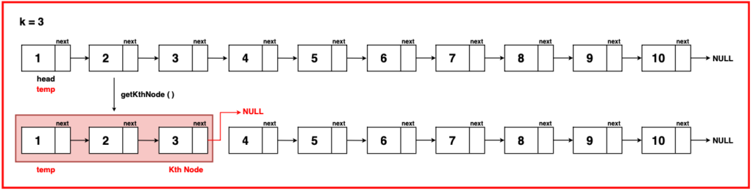
Step 3: Treat this segment from `temp` to Kth Node as an individual linked list and reverse it. This can be done via the help of a helper function `reverseLinkedList` which has been discussed in detail in this article Reverse Linked List.
Step 4: The reversed linked list segment returns a modified list with `temp` now at its tail and the `KthNode` pointing to its head. Update the `temp`s `next` pointer to `nextNode`.
If we are at the first segment of K nodes, update the head to `Kth Node`.
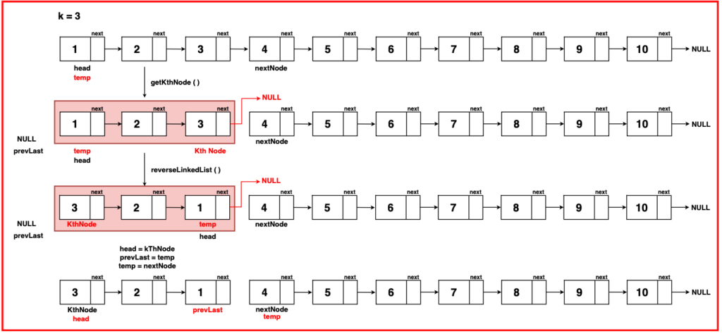
Step 5: Continue this reversal for further groups. If a segment has fewer than K Nodes, leave them unmodified and return the new head. Use the prevLast pointer to maintain the link between the end of the previous reversed segment and the current segment.
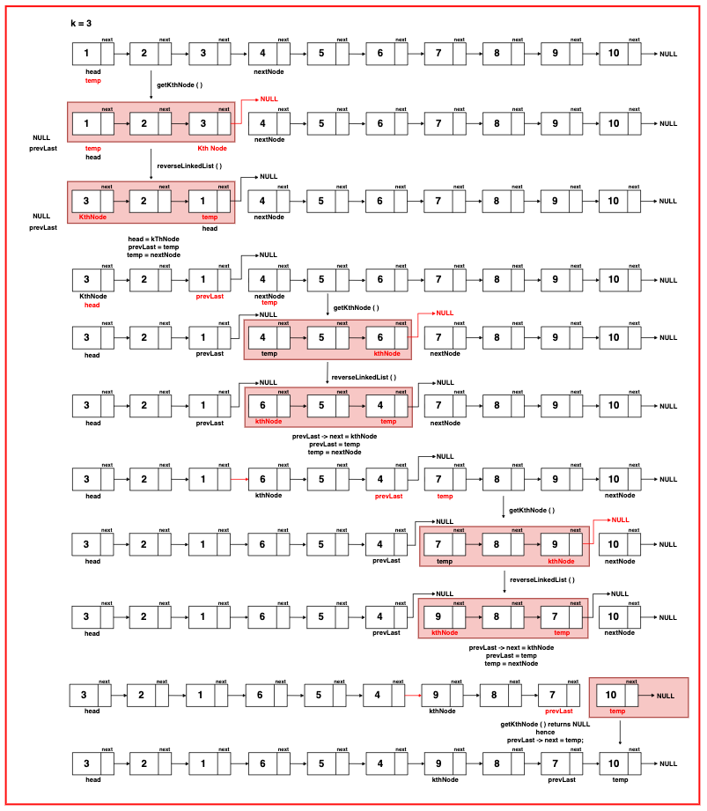

import java.util.*;

// Node class represents a
// node in a linked list
class Node {
// Data stored in the node
int data;
// Pointer to the next
// node in the list
Node next;

// Constructor with both data
// and next node as parameters
Node(int data, Node next) {
this.data = data;
this.next = next;
}

// Constructor with only data as
// a parameter, sets next to null
Node(int data) {
this.data = data;
this.next = null;
}
}
public class Main {

// Function to reverse a linked list
// using the 3-pointer approach
static Node reverseLinkedList(Node head) {
// Initialize'temp' at
// head of linked list
Node temp = head;

// Initialize pointer 'prev' to NULL,
// representing the previous node
Node prev = null;

// Traverse the list, continue till
// 'temp' reaches the end (NULL)
while(temp != null){
// Store the next node in
// 'front' to preserve the reference
Node front = temp.next;

// Reverse the direction of the
// current node's 'next' pointer
// to point to 'prev'
temp.next = prev;

// Move 'prev' to the current
// node for the next iteration
prev = temp;

// Move 'temp' to the 'front' node
// advancing the traversal
temp = front;
}

// Return the new head of
// the reversed linked list
return prev;

}

// Function to get the Kth node from
// a given position in the linked list
static Node getKthNode(Node temp, int k) {
// Decrement K as we already
// start from the 1st node
k -= 1;

// Decrement K until it reaches
// the desired position
while (temp != null && k > 0) {
// Decrement k as temp progresses
k--;

// Move to the next node
temp = temp.next;
}

// Return the Kth node
return temp;
}

// Function to reverse nodes in groups of K
static Node kReverse(Node head, int k) {
// Initialize a temporary
// node to traverse the list
Node temp = head;

// Initialize a pointer to track the
// last node of the previous group
Node prevLast = null;

// Traverse through the linked list
while (temp != null) {

// Get the Kth node of the current group
Node kThNode = getKthNode(temp, k);

// If the Kth node is NULL
// (not a complete group)
if (kThNode == null) {

// If there was a previous group,
// link the last node to the current node
if (prevLast != null) {
prevLast.next = temp;
}

// Exit the loop
break;
}

// Store the next node
// after the Kth node
Node nextNode = kThNode.next;

// Disconnect the Kth node
// to prepare for reversal
kThNode.next = null;

// Reverse the nodes from
// temp to the Kth node
reverseLinkedList(temp);

// Adjust the head if the reversal
// starts from the head
if (temp == head) {
head = kThNode;
} else {
// Link the last node of the previous
// group to the reversed group
prevLast.next = kThNode;
}

// Update the pointer to the
// last node of the previous group
prevLast = temp;

// Move to the next group
temp = nextNode;
}

// Return the head of the
// modified linked list
return head;
}
}
Time Complexity: O(2N) The time complexity consists of actions of reversing segments of K and finding the Kth node which operates in linear time. Thus, O(N) + O(N) = O(2N), which simplifies to O(N).
Space Complexity: O(1) The space complexity is O(1) as the algorithm operates in place without any additional space requirements.

